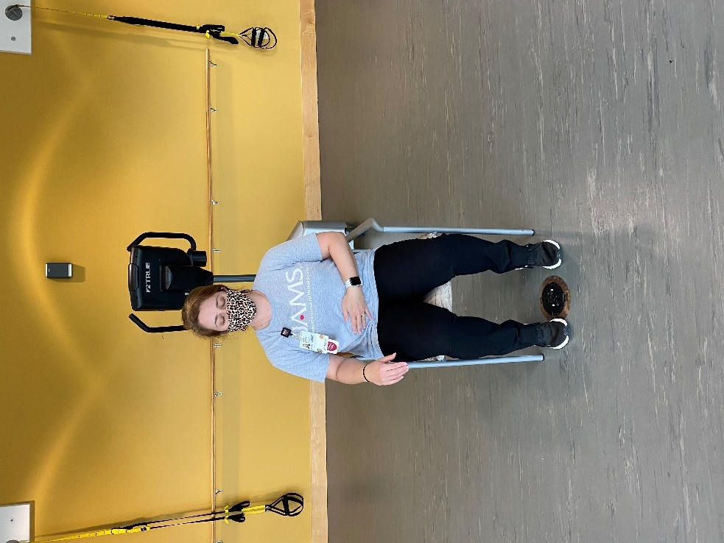

Belly Breathing

Sit with both feet flat on the floor.
Place one hand on your abdomen.
Take a deep breath in through your nose until you fill up your lungs and inflate your stomach.
Breath out through your mouth and try to push out as much air as possible.
Repeat for as many times as you can in a 3-5 minute span.

*You can do this for any allotted time!
**If you are lightheaded, slow your breathing back to normal and you should feel better. Stay seated.
***Don’t hold your breath, just steady breathing to relax.

